Zoology Honors Thesis

“The Effects of Deer and an Invasive Shrub, Lonicera maackii, on Woody Seedlings
and Forest Floor Plant Composition”

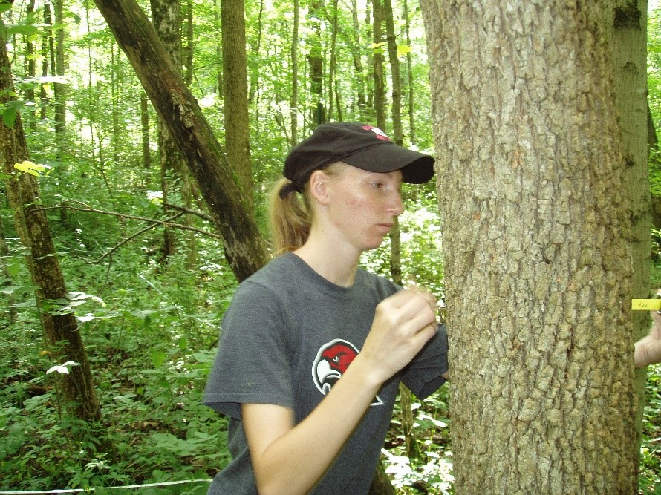

Christina Haffey

Friday, December 8, 2017
1:15 PM
15 Upham Hall

For more information, please contact
Dr. David Gorchov: gorchodl@miamioh.edu

